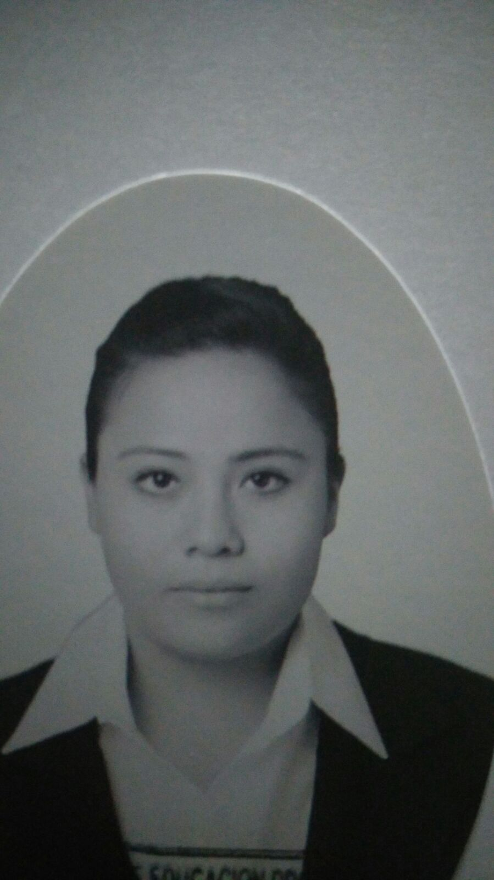

**LILIA ISABEL ROJAS NOGUEZ**

**Birthdate:** 15/october/1994.

**Age:** 22.

**CURP:** RONL941015MGTJGL03

**Address:** Prol. Acueducto #168 Col. San Isidro.

**Telephone:** 6099001 **Cellphone:** (044) 4171048186

**Email:** isa_lili@hotmail.com

**Civil Status:** Single. **Nationality:** Mexican.

**PROFESSIONAL OBJECT IVE**



Develop a project that meets the needs of the organization, performing the acquired skills of my studies in an effective and positive way for the company. Providing an efficient performance in the assigned position with responsibility and professionalism.

**PERSONAL OBJECTIVE**

Overcome in all aspects of my life, providing the best all days.

**Career:** Universidad Tecnológica de León Campus Acámbaro.

**Address:** Carretera Acámbaro-Tarandacuao, Km 8.

**Colony:** San Miguel del Puerto.

**Telephone:** 15 50 600

**Year:** September 2016 and currently studiying.

**Career:** Universidad Tecnológica de León Campus Acámbaro.

**Address:** Carretera Acámbaro-Tarandacuao, Km 8.

**Colony:** San Miguel del Puerto.

**Telephone:** 15 50 600

**Titulo:** En tramite

**Average:** 9

**Year:** September 2014 – August 2016.

**Career:** Colegio Nacional de Educación Profesional Técnica Plantel Acámbaro.

**Address:** Carretera Acambaro - Salvatierra Km 2.5,

**Colony:** Acambaro Centro.

**Telephone:** 01 417 172 2206

**Average:** 8.6

**Year:** September 2010 – August 2014.

**ACADEMIC FORMATION**

**WORK EXPERIENCE**

**Company name:** Panificadora Loeza Hermanos.

**Job:** Programer.

**Period:** May - August 2016.

**Main activities:** Development of an advertising website through the use of the WordPress content management system in order to provide the company with more advertising tools and position it in the technological field.

**LANGUAGES**



Castellano - Lengua materna.

Inglés – Básic level 20%.

**COMPUTERS SKILLS**



**Skills:** Maintenance of computer equipment, knowledge in some programming languages, audio and video editing, multimedia program management, 3D animation, graphic design.

**Programming software:**

* Microsoft office 90%.
* Corel Draw 80%.
* Camtasia Studio 90%.
* Movie Maker 70%.
* Adobe Fireworks 80%.
* Adobe Director 70%.
* Audacity 80%.
* Sound Forge Pro 80%.
* Blender 70%.

**Programming language:**

* PHP 60%.
* Java 70%.
* CSS 50%.

**TIME AVAILABILITY**



I have a full time availability

**OTHER DATA OF INTEREST**

**Congress:** 9° Congreso Internacional de Calidad en la ciudad de León Guanajuato.

In the personal, I consider myself to be quiet patience, perseverance and open to any change.